Quiz-answers.txt

1,3

3,4,5

1,2,3

Task 1: You want to draw the face of your friend on a canvas:
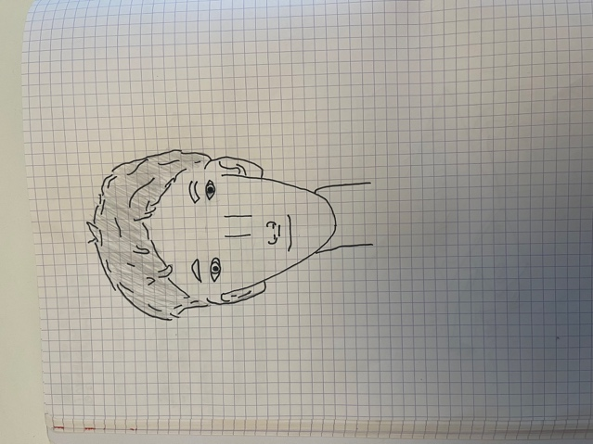

Task 2: You want to plan a bikepacking trip for n days and want to plan your trip to another country. You assume an average speed of 20 km/h. You want to bike about 6 hours per day. For warming up, you plan only 3 hours on the first day:
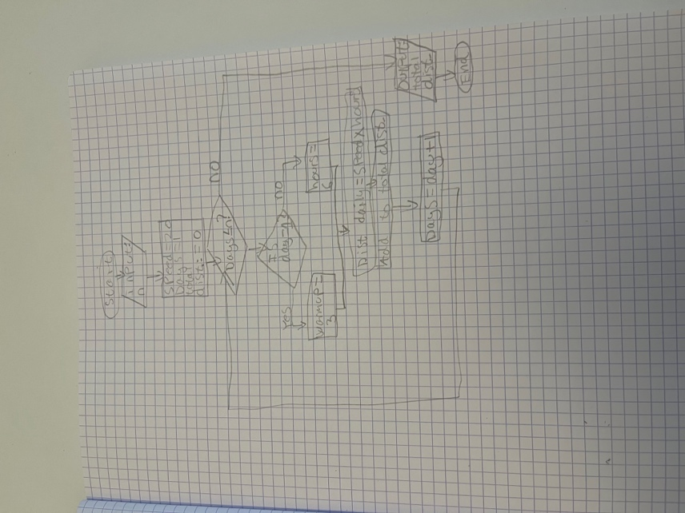

Task 3: You are an engineer at Uber:
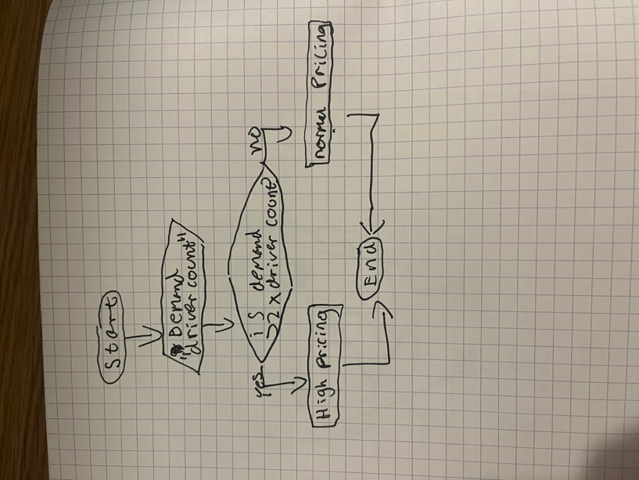

Task 4: Yoou are a programming a role playing game. You want to code the effect of an attack:
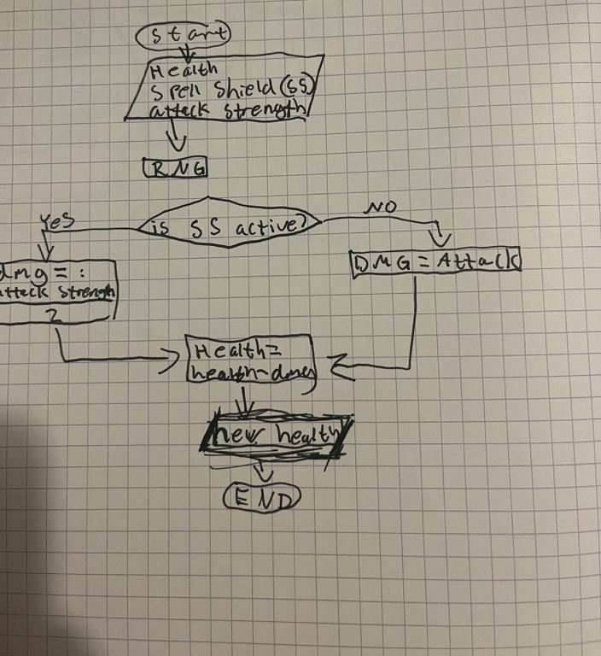

Task 5: You are coding part of a first person shooter game:
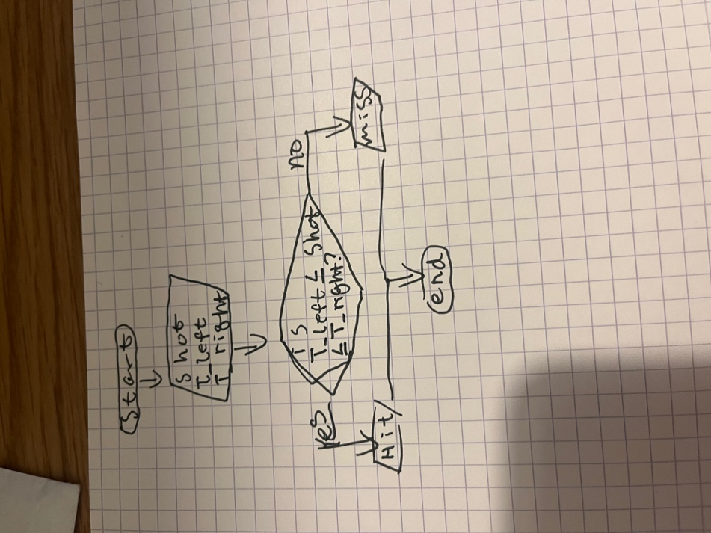

Task 6: You are coding an app for calculating requiered protein intake for fitness:
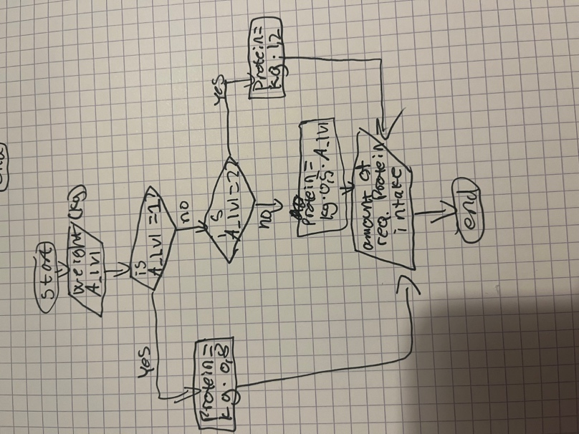

Task 7:
You are a ham radio operator who wants to record distant stations:
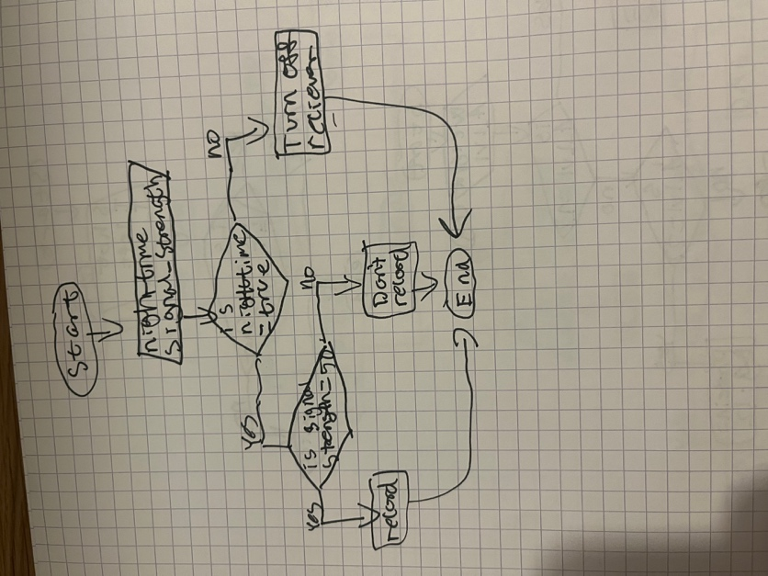

Task 8:
You ate with your friends in a restaurant and want to split the bill:
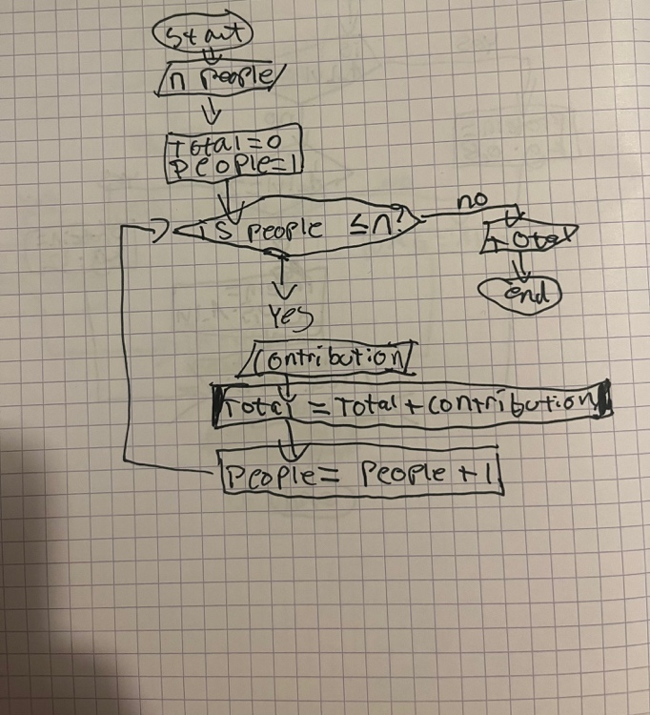

Task 9: You are cutting a piece of string with length string_length into equal pieces of peice_length.
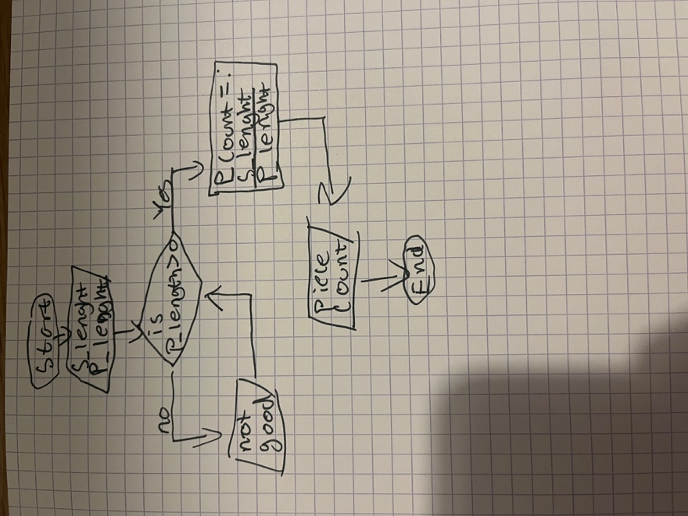
Task 10: Finally, find a process from your daily life:
